Control Lesson 2 Intro to Vehicle Control

[1. Sebastian Introduction](https://classroom.udacity.com/nanodegrees/nd787/parts/3619d672-ce5b-4a29-8a15-172cb667b5bb/modules/b78ec22c-5afe-444b-8719-b390bd2b2988/lessons/dd98d695-14f1-40e0-adc5-e9fafe556f73/concepts/acf481cc-f376-473a-a4e2-927a9ceabfa0)

<https://www.youtube.com/watch?time_continue=3&v=bTJTGOz-0Dg>

[2. Lesson Introduction](https://classroom.udacity.com/nanodegrees/nd787/parts/3619d672-ce5b-4a29-8a15-172cb667b5bb/modules/b78ec22c-5afe-444b-8719-b390bd2b2988/lessons/dd98d695-14f1-40e0-adc5-e9fafe556f73/concepts/9763a631-a3d0-4443-8a94-5d60d2c93a17)

<https://www.youtube.com/watch?v=Gn78zDvSD8Q>

[3. Perfect Control](https://classroom.udacity.com/nanodegrees/nd787/parts/3619d672-ce5b-4a29-8a15-172cb667b5bb/modules/b78ec22c-5afe-444b-8719-b390bd2b2988/lessons/dd98d695-14f1-40e0-adc5-e9fafe556f73/concepts/82bf45f7-b0b7-49a7-898f-b445641480ea)

<https://www.youtube.com/watch?v=iBoH3NdSK-8>

[4. The problem with open loop control Exercise](https://classroom.udacity.com/nanodegrees/nd787/parts/3619d672-ce5b-4a29-8a15-172cb667b5bb/modules/b78ec22c-5afe-444b-8719-b390bd2b2988/lessons/dd98d695-14f1-40e0-adc5-e9fafe556f73/concepts/5555596e-c509-422f-91c3-7c953eb0db6b)

[Open Loop.ipynb](https://viewb9633d84.udacity-student-workspaces.com/notebooks/Open%20Loop.ipynb)

[5. Perfect is Impossible](https://classroom.udacity.com/nanodegrees/nd787/parts/3619d672-ce5b-4a29-8a15-172cb667b5bb/modules/b78ec22c-5afe-444b-8719-b390bd2b2988/lessons/dd98d695-14f1-40e0-adc5-e9fafe556f73/concepts/100acf3c-8bdf-401b-a3f6-22e6fe680bfb)

<https://www.youtube.com/watch?v=uo-BqviC6QY>

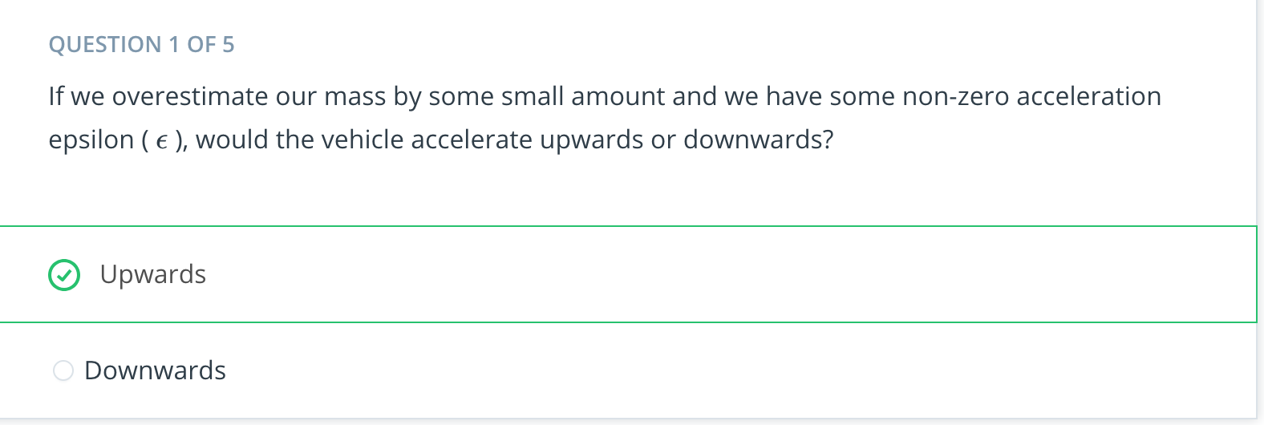

<https://www.youtube.com/watch?v=uezdQ5itsBM>

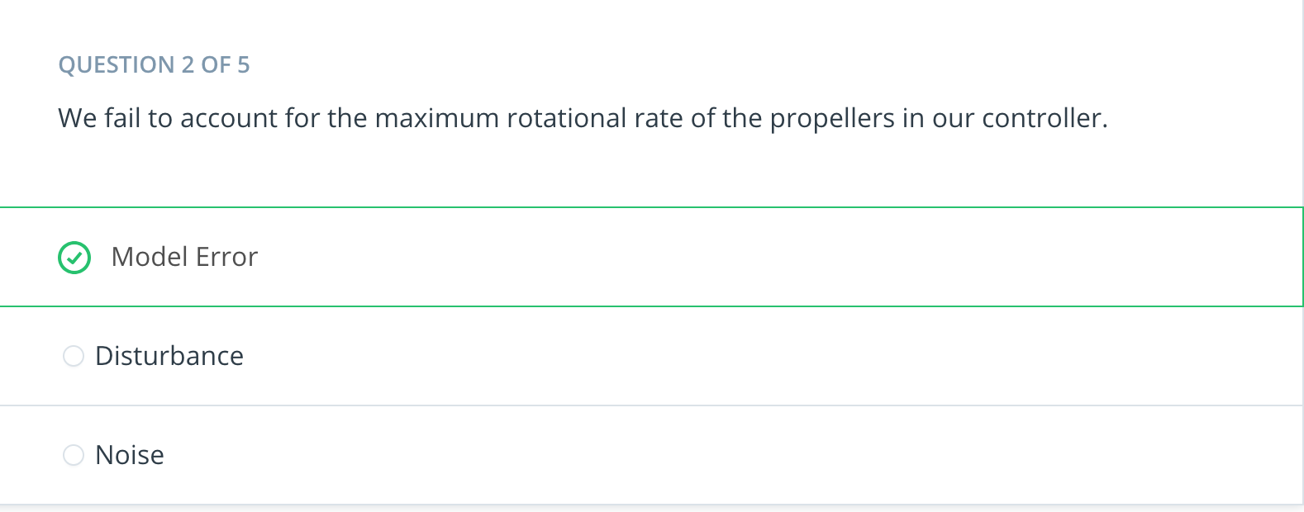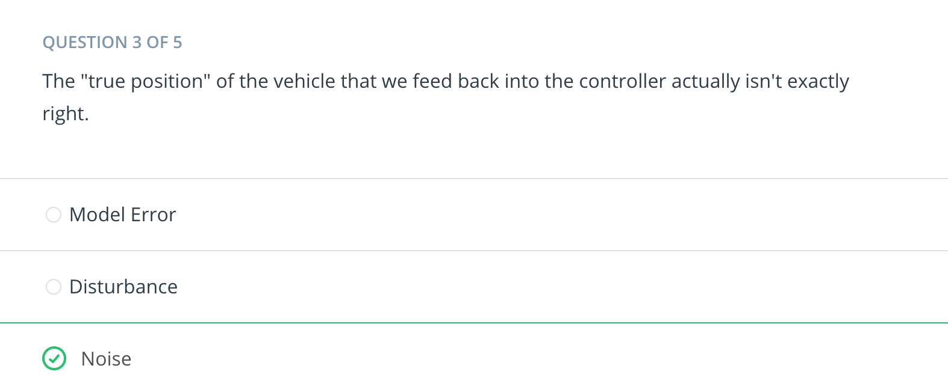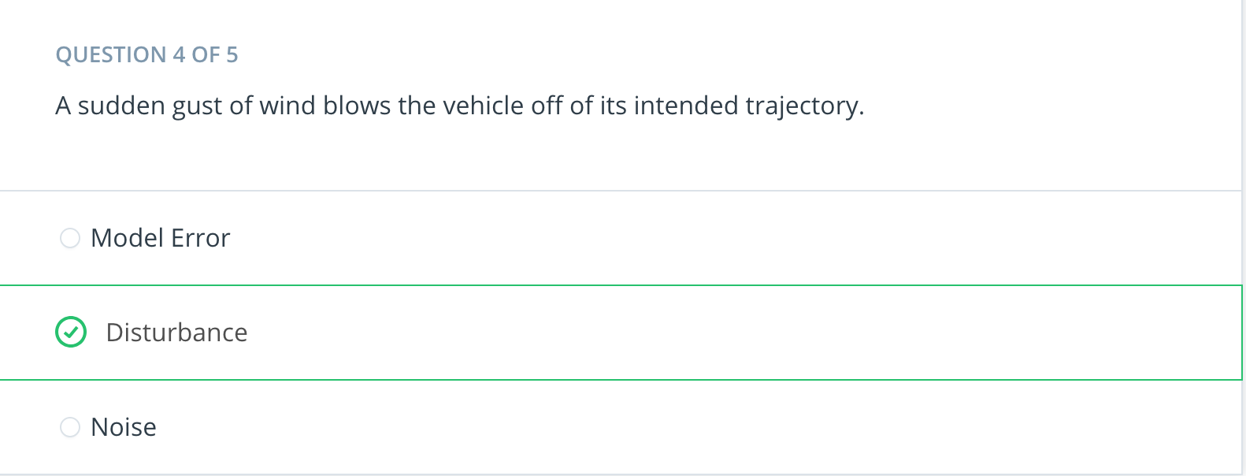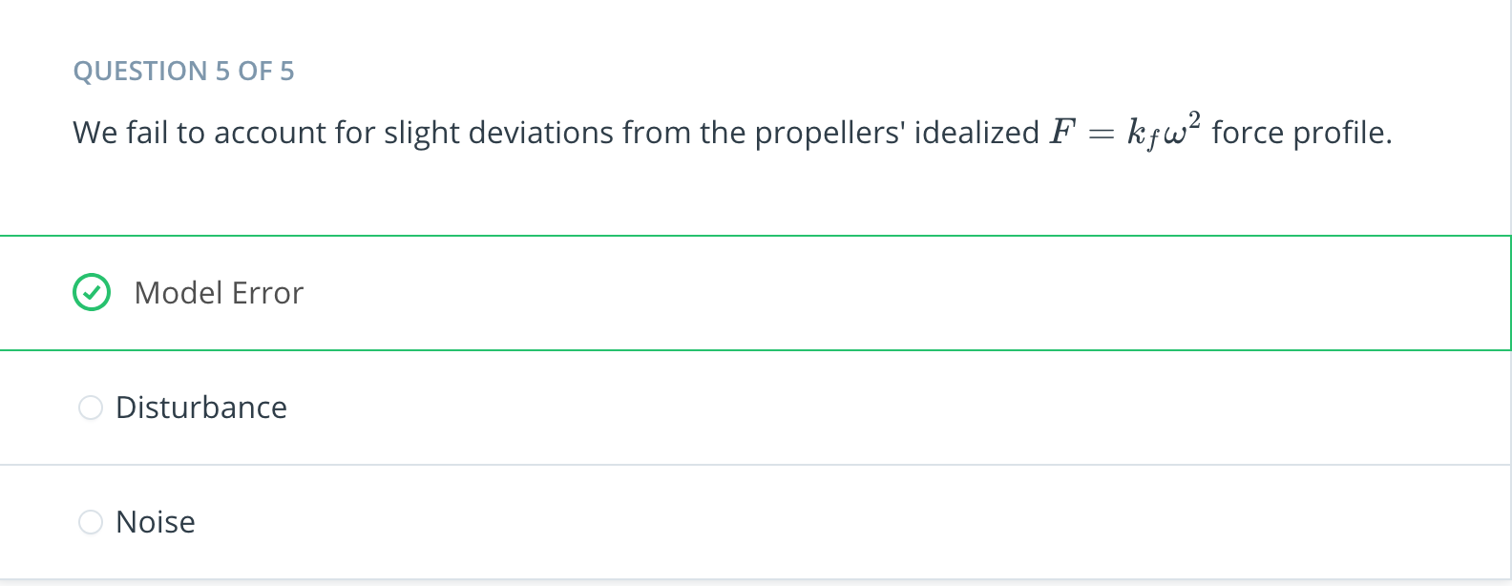

[6. Simple Control Diagrams](https://classroom.udacity.com/nanodegrees/nd787/parts/3619d672-ce5b-4a29-8a15-172cb667b5bb/modules/b78ec22c-5afe-444b-8719-b390bd2b2988/lessons/dd98d695-14f1-40e0-adc5-e9fafe556f73/concepts/bc9a6bce-b6e1-4c33-8c91-1d6318f80381)

[7. P Controllers](https://classroom.udacity.com/nanodegrees/nd787/parts/3619d672-ce5b-4a29-8a15-172cb667b5bb/modules/b78ec22c-5afe-444b-8719-b390bd2b2988/lessons/dd98d695-14f1-40e0-adc5-e9fafe556f73/concepts/1b73f2a8-8aff-4209-b79c-eb847b1c891c)

[8. Implement P Controller Exercise](https://classroom.udacity.com/nanodegrees/nd787/parts/3619d672-ce5b-4a29-8a15-172cb667b5bb/modules/b78ec22c-5afe-444b-8719-b390bd2b2988/lessons/dd98d695-14f1-40e0-adc5-e9fafe556f73/concepts/3b983b06-5363-4b2d-8632-ec8009dec5a9)

[9. Two Problems with P Control](https://classroom.udacity.com/nanodegrees/nd787/parts/3619d672-ce5b-4a29-8a15-172cb667b5bb/modules/b78ec22c-5afe-444b-8719-b390bd2b2988/lessons/dd98d695-14f1-40e0-adc5-e9fafe556f73/concepts/a2dddcd0-cda6-4ae6-ade1-2af8ef07b6c5)

[10. P Controller Tuning Exercise](https://classroom.udacity.com/nanodegrees/nd787/parts/3619d672-ce5b-4a29-8a15-172cb667b5bb/modules/b78ec22c-5afe-444b-8719-b390bd2b2988/lessons/dd98d695-14f1-40e0-adc5-e9fafe556f73/concepts/2332aed6-bb90-41be-8874-644a09821462)[s with P Control](https://classroom.udacity.com/nanodegrees/nd787/parts/3619d672-ce5b-4a29-8a15-172cb667b5bb/modules/b78ec22c-5afe-444b-8719-b390bd2b2988/lessons/dd98d695-14f1-40e0-adc5-e9fafe556f73/concepts/a2dddcd0-cda6-4ae6-ade1-2af8ef07b6c5)

[11. Limitations of P Control](https://classroom.udacity.com/nanodegrees/nd787/parts/3619d672-ce5b-4a29-8a15-172cb667b5bb/modules/b78ec22c-5afe-444b-8719-b390bd2b2988/lessons/dd98d695-14f1-40e0-adc5-e9fafe556f73/concepts/ac24ffdb-dad7-4f90-bcf0-631aad5c4c1e)

[12. PD Control](https://classroom.udacity.com/nanodegrees/nd787/parts/3619d672-ce5b-4a29-8a15-172cb667b5bb/modules/b78ec22c-5afe-444b-8719-b390bd2b2988/lessons/dd98d695-14f1-40e0-adc5-e9fafe556f73/concepts/8db99438-a16a-4f2b-9ca2-794de97ffa43)

[13. Implement PD Controller Exercise](https://classroom.udacity.com/nanodegrees/nd787/parts/3619d672-ce5b-4a29-8a15-172cb667b5bb/modules/b78ec22c-5afe-444b-8719-b390bd2b2988/lessons/dd98d695-14f1-40e0-adc5-e9fafe556f73/concepts/70f11f12-8188-4c73-afe9-c22b354583ca)

[14. PD Incorporating Feedforward Control](https://classroom.udacity.com/nanodegrees/nd787/parts/3619d672-ce5b-4a29-8a15-172cb667b5bb/modules/b78ec22c-5afe-444b-8719-b390bd2b2988/lessons/dd98d695-14f1-40e0-adc5-e9fafe556f73/concepts/eb1ff4a3-b0f0-400f-8553-b92295447c25)

[15. Implement PD with Feedforward Exercise](https://classroom.udacity.com/nanodegrees/nd787/parts/3619d672-ce5b-4a29-8a15-172cb667b5bb/modules/b78ec22c-5afe-444b-8719-b390bd2b2988/lessons/dd98d695-14f1-40e0-adc5-e9fafe556f73/concepts/ca1383f5-01b2-4781-bb82-d727710823ff)

[16. PD Math and Reparametrization](https://classroom.udacity.com/nanodegrees/nd787/parts/3619d672-ce5b-4a29-8a15-172cb667b5bb/modules/b78ec22c-5afe-444b-8719-b390bd2b2988/lessons/dd98d695-14f1-40e0-adc5-e9fafe556f73/concepts/f09eed19-6743-4c5e-8fd6-4ca68a199970)

[17. Overshoot, Rise Time, Settling Time](https://classroom.udacity.com/nanodegrees/nd787/parts/3619d672-ce5b-4a29-8a15-172cb667b5bb/modules/b78ec22c-5afe-444b-8719-b390bd2b2988/lessons/dd98d695-14f1-40e0-adc5-e9fafe556f73/concepts/541ec6ae-f171-4195-9c05-97a5c82a85df)

[18. More Model Errors](https://classroom.udacity.com/nanodegrees/nd787/parts/3619d672-ce5b-4a29-8a15-172cb667b5bb/modules/b78ec22c-5afe-444b-8719-b390bd2b2988/lessons/dd98d695-14f1-40e0-adc5-e9fafe556f73/concepts/62fa83b8-3435-4c78-a0b7-992ff8b714b2)

[19. PID Control](https://classroom.udacity.com/nanodegrees/nd787/parts/3619d672-ce5b-4a29-8a15-172cb667b5bb/modules/b78ec22c-5afe-444b-8719-b390bd2b2988/lessons/dd98d695-14f1-40e0-adc5-e9fafe556f73/concepts/507c4448-87c7-4e1b-80a0-36ec38330888)

[20. PID Control Exercise](https://classroom.udacity.com/nanodegrees/nd787/parts/3619d672-ce5b-4a29-8a15-172cb667b5bb/modules/b78ec22c-5afe-444b-8719-b390bd2b2988/lessons/dd98d695-14f1-40e0-adc5-e9fafe556f73/concepts/376cb237-8c63-4be5-b5e2-ee628dab64cd)

[21. Summary](https://classroom.udacity.com/nanodegrees/nd787/parts/3619d672-ce5b-4a29-8a15-172cb667b5bb/modules/b78ec22c-5afe-444b-8719-b390bd2b2988/lessons/dd98d695-14f1-40e0-adc5-e9fafe556f73/concepts/a47ffb63-4810-48eb-b046-acafe668105b)